**LED CHASER**

CIRCUIT DIAGRAM

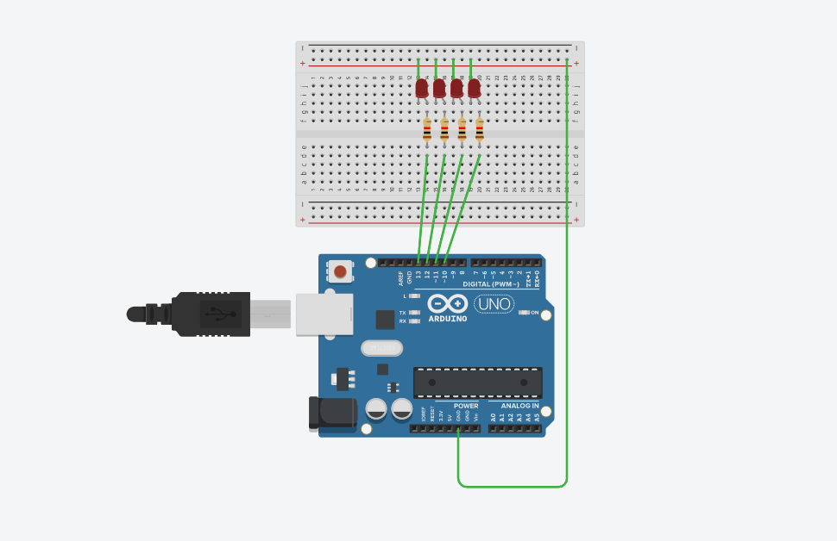

CONCEPT USED:

We know that “LED” stands for light emitting diode, which glows when the current is provided to it .

To make a group of LED blink in pattern

We use Arduino to do such work for us.

By writing a code for Arduino to perform the blinking of “LED”.

Use of knowledge of coding (loop: for loop).

Knowledge of Arduino software.

Knowledge of positive - negative terminal of “LED”, circuits, Breadboard.

Learning & Observations:

1: Arduino can output 5v while connected to pc with power cord.

2: Arduino has three ground pins.

3: Arduino has both digital and analog pins

4: Digital pins are for OUTPUT and INPUT both.

5: Analog pins are only for INPIUT only.

Problems & Troubleshooting:

1: Wrong Board selection in Arduino program.(select Arduino-uno in board selection menu )

2: Used wrong coding or wrong pins(write correct pin while coding and connect correct pins while preparing hardware).

Precautions:

1: Choose correct board in Arduino software.

2: Code properly otherwise the led won’t glow or it might not blink.

3: Connect the circuit properly and correctly.

4: don’t forget to connect Arduino to computer.

Learning Outcomes:

1: How to blink an led in pattern using Arduino.

2: Proper use of loop.

3: Where is positive and negative terminal of “LED”.

4: How breadboard works.

5: How Arduino works.